CSE 333 - OPERATING SYSTEMS

Programming Assignment # 1 Report

1-) myprog1.sh

# Shell script to test if a string is a palindrome. We control input is entered or not. Then we compare and iterate first character of string is same with last character of string by while loop.

Error control:

##control input is entered or not

##control head of string is equal to end of string or not

##control number of entered arguments

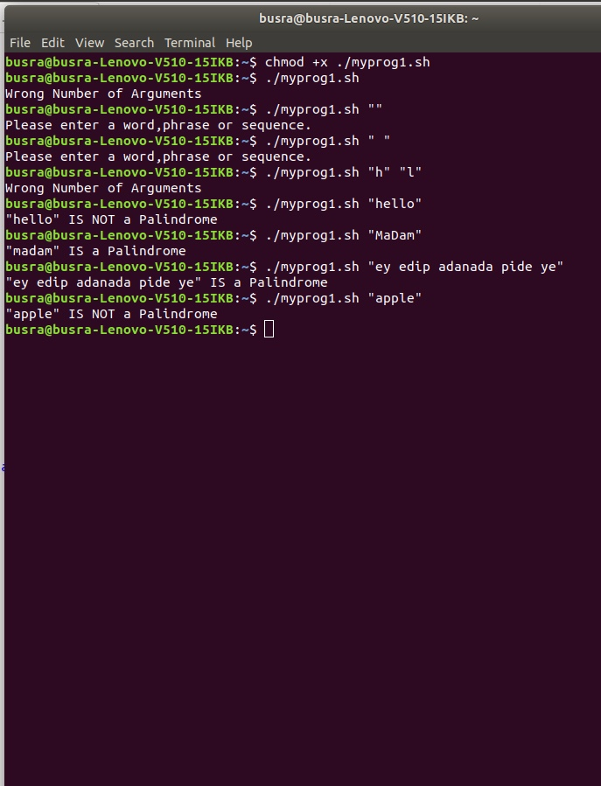

2-) myprog2.sh

# We have inputs and then control inputs are integer or not. If first input bigger than second input and difference of this inputs is even start the for loops. We print stars in first for loop by difference of inputs, print spaces by smaller input and then again print stars with first loop.

Error control:

## control how many input is entered

##control i1 and i2 is integer or not

## control i1>i2 and difference between i1 and i2 is even or not

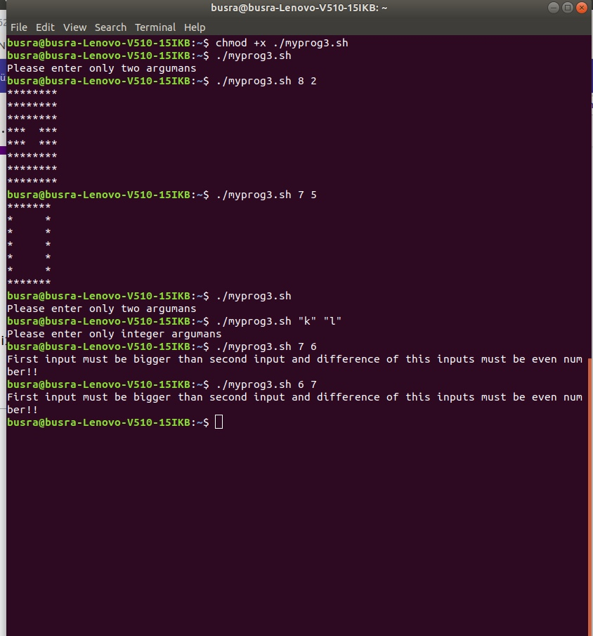

3-) myprog3.sh

4-) myprog4.sh

# We take pathname and wildcard as inputs. And then control input number is correct or not. And we find a wildcard “*” position in word by if condition and we defined array to keep txt names that contain given wildcard.And search given wildcard in given path by recursively. If this words assign given wildcard and they are matching uppercase this words, we change this updated uppercase words in txt files in pathname. If there are one input (only wildcard) taken, we repeat same process with only one input in current directory.

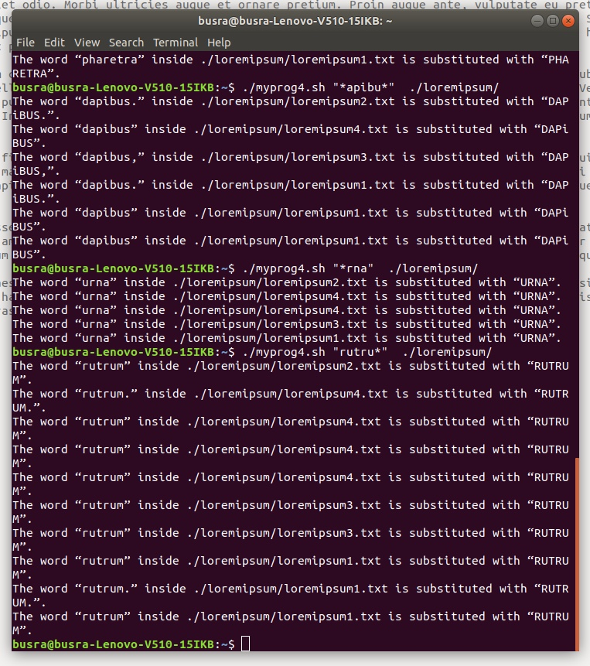

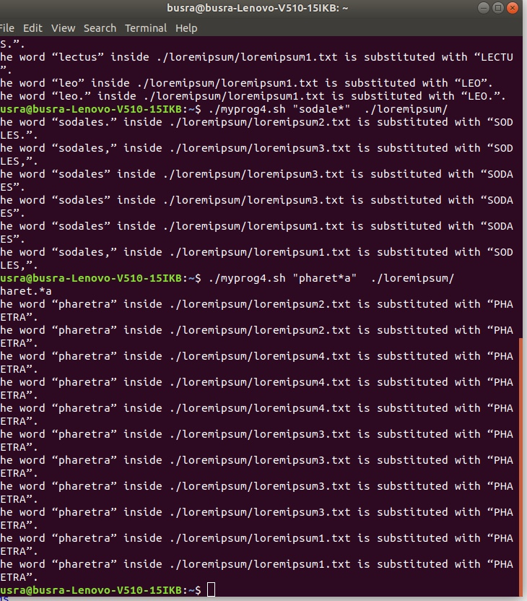

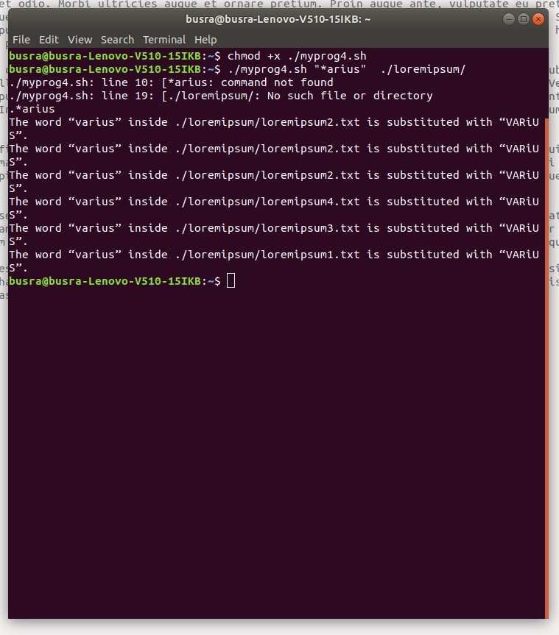

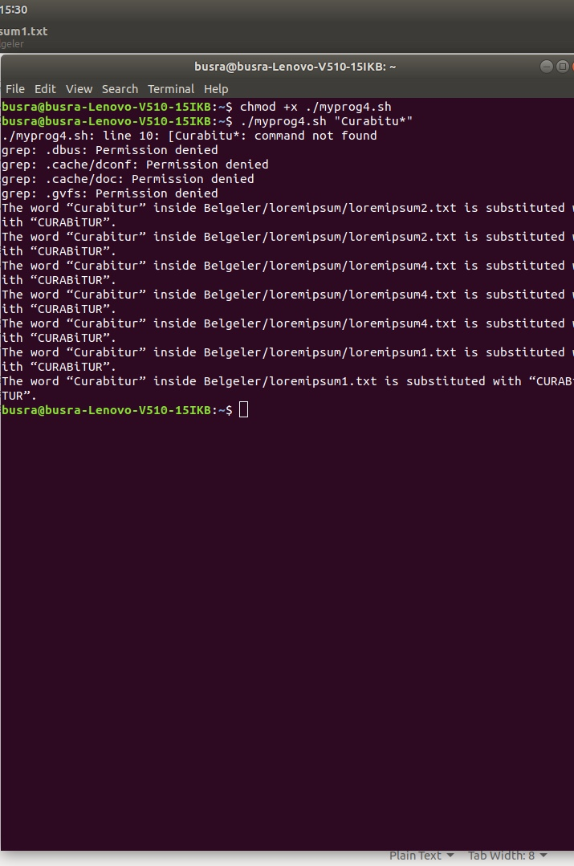

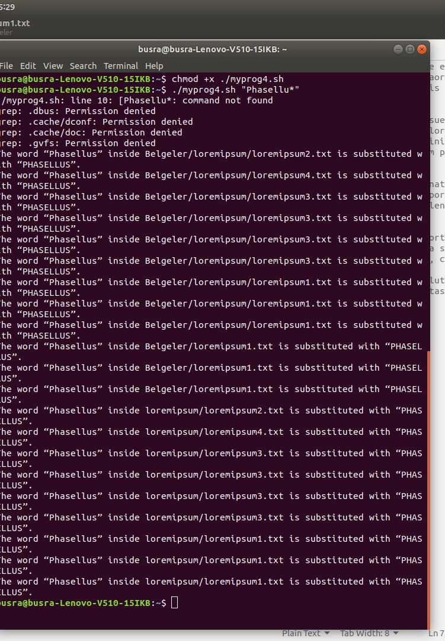

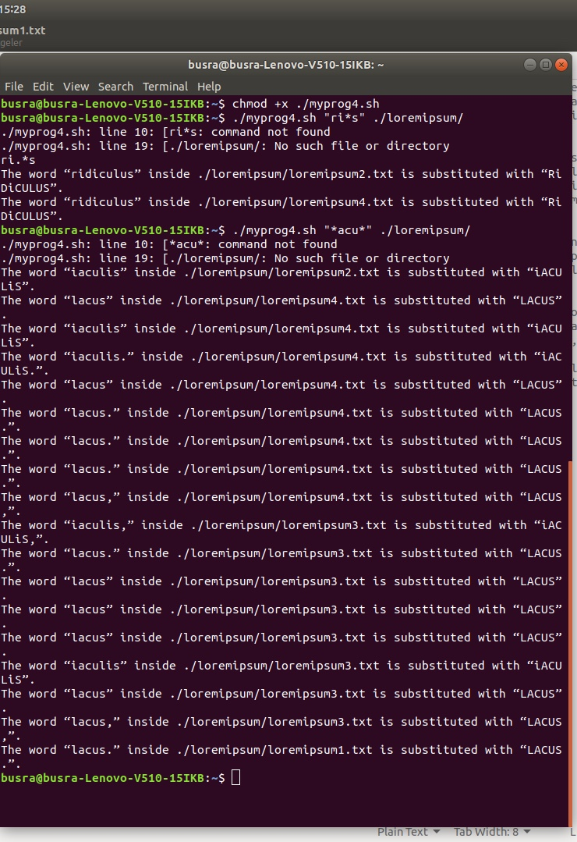

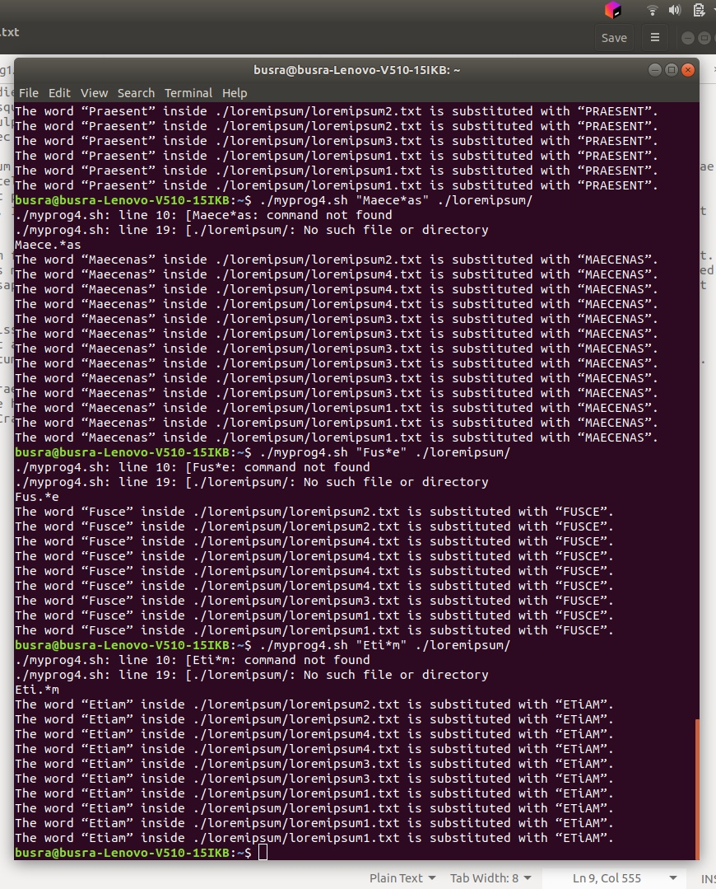

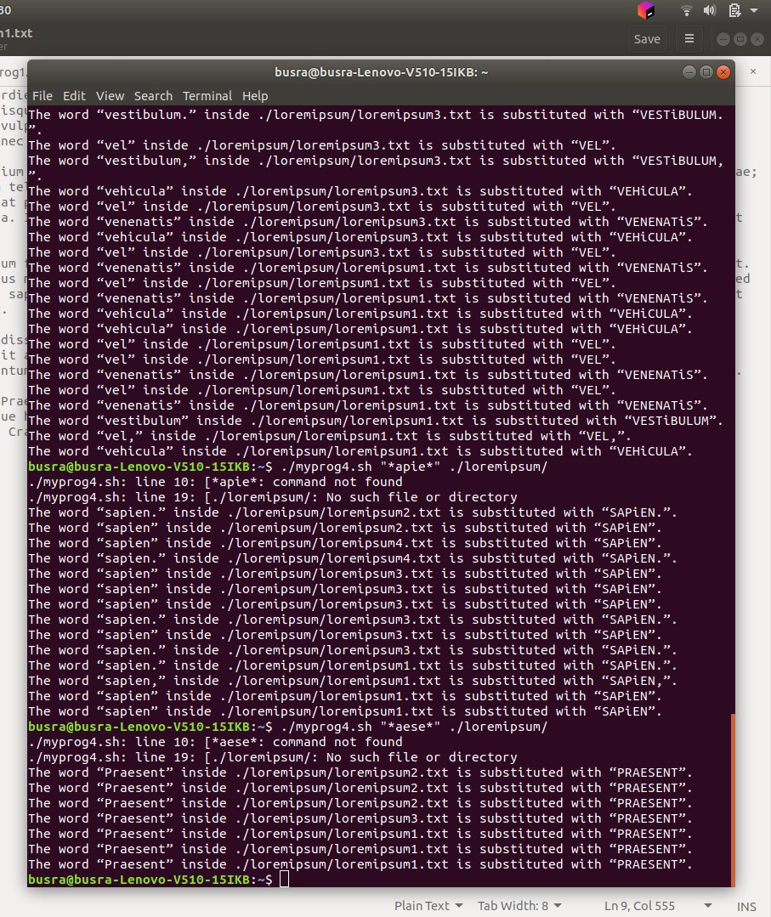

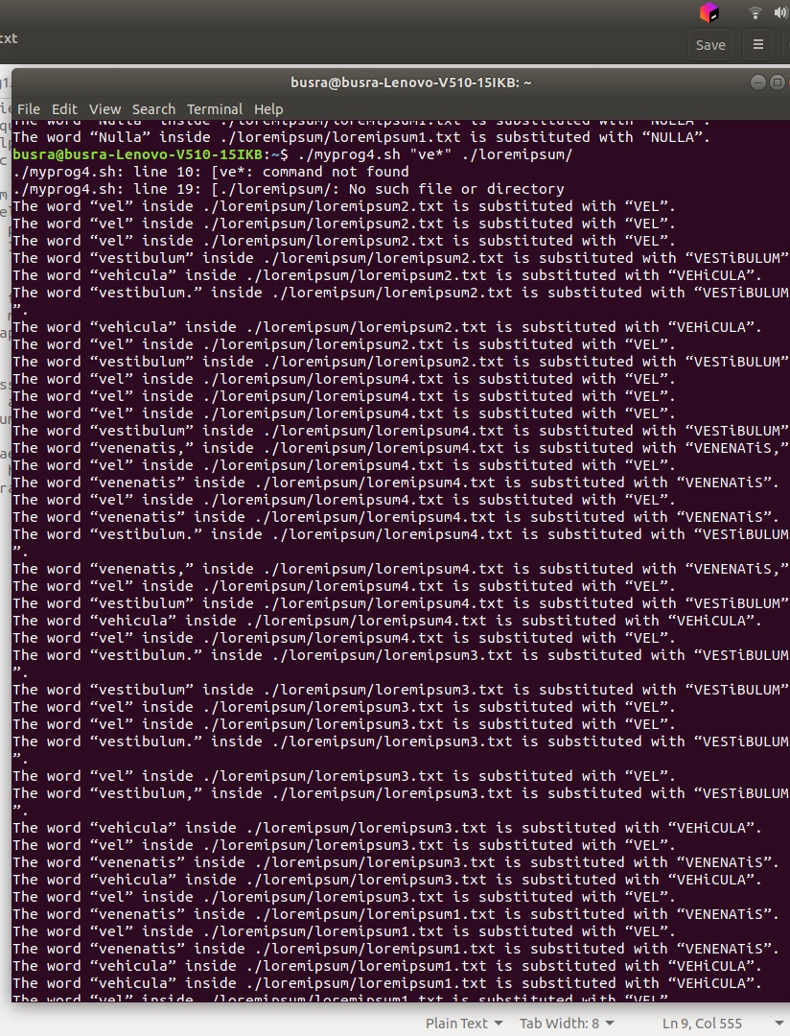

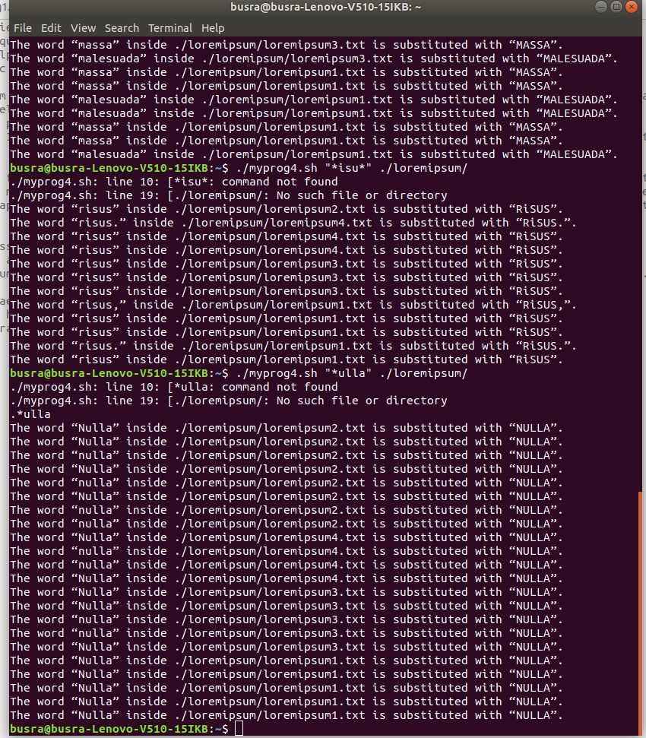

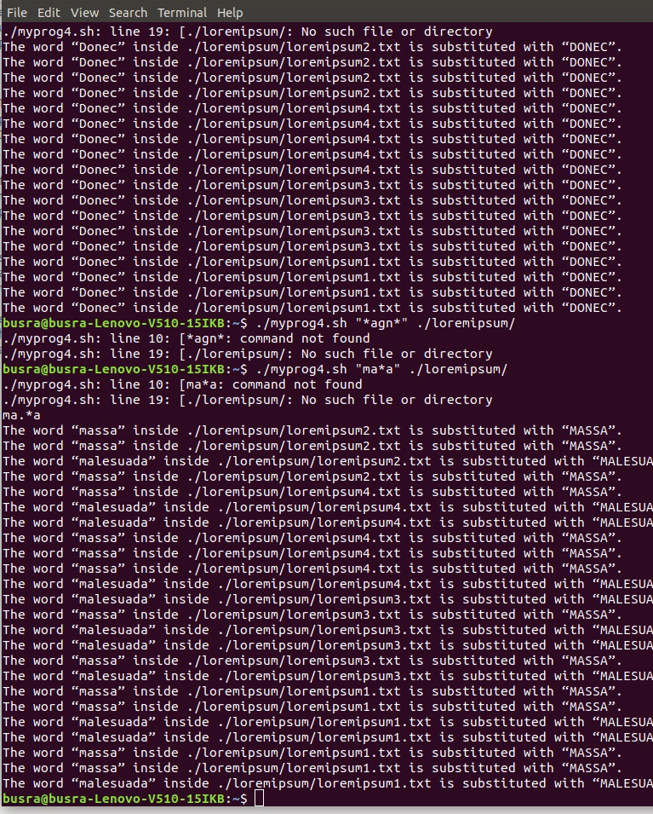

Error Control:

#Invalid input, your input must be a wildcard

# Invalid input number, please enter one or two input

#number of input

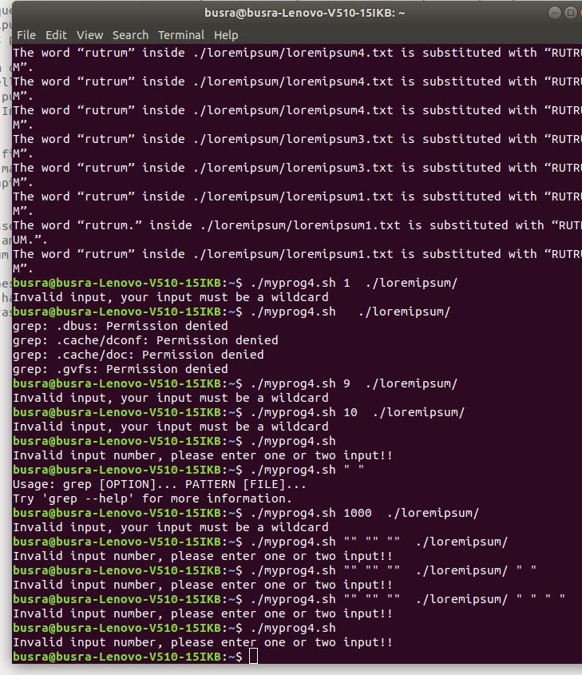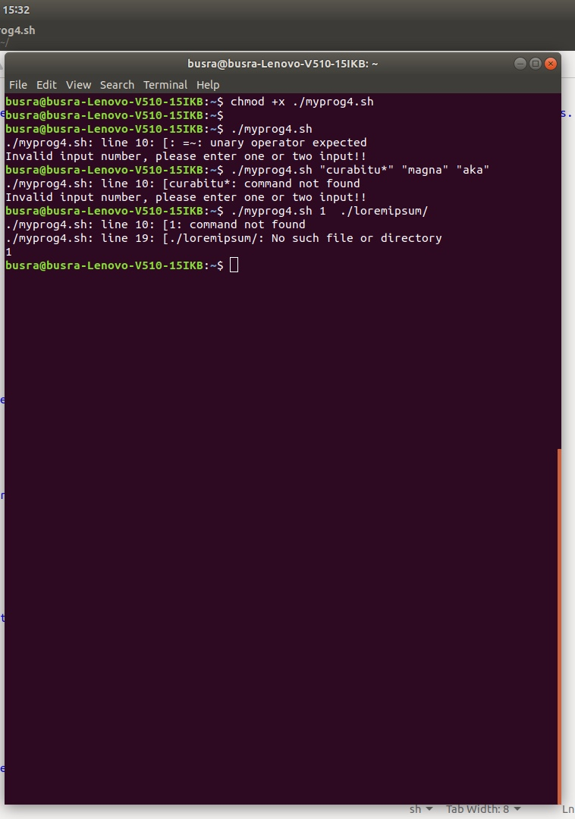

5-) myprog5.sh

6-) menu.sh

Büşra GÖKMEN

Ömer AĞAOĞLU